Spike Proteins & the Power of Fulvic/Humic Acid
What are Spike Proteins?
Spike proteins allow viruses to penetrate host cells and cause infection.
Viruses must break into our cells to set up an infection. It gains entry using the now notorious spike protein but, typical of viruses, it must hijack our own biology to jimmy the lock. Scientists are figuring out ways to intercept the virus before it can break in.
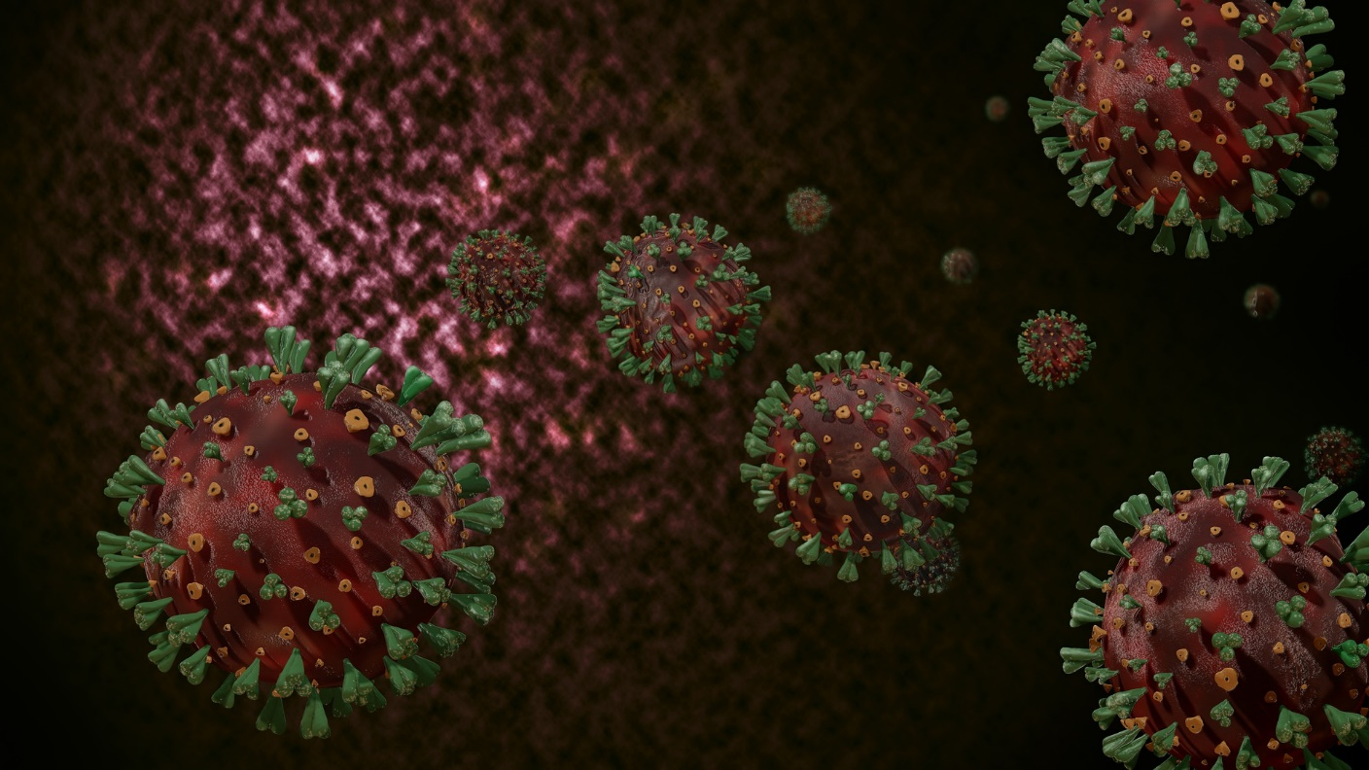
Spike proteins work a bit like shape-shifting lock picks. They can change shape to interact with a protein on the surface of human cells. Those spike proteins latch the virus onto a cell. This allows them to get entry into those cells.
Without the spike protein, viruses would not be able to interact with the cells of potential hosts like animals and humans to cause infection. As a result, the S protein represents an ideal target for vaccine and antiviral research endeavors.
As compared to the M and E proteins that are primarily involved in virus assembly, the S protein plays a crucial role in penetrating host cells and initiating infection.
The S protein is a highly glycosylated and large type I transmembrane fusion protein that is made up of 1,160 to 1,400 amino acids, depending upon the type of virus.
Members of certain viral families have sharp bumps that protrude from the surface of their outer envelopes. Those bumps are known as spike proteins.
They’re actually glycoproteins. That means they contain a carbohydrate (such as a sugar molecule). Spiked proteins are what give the viruses their name.
Under the microscope, those spikes can appear like a fringe or crown (and corona is Latin for crown).
Fulvic/Humic Acid
Fulvic acid is one component of humus. Humus is made of many organic compounds found in the Earth’s soils, rock sediments and bodies of water.
Fulvic acid is created by gradual decomposition of certain plants and animals by the action of microorganisms.
Because Fulvic acid is able to improve how our cells use things like antioxidants and electrolytes, it’s become popular for slowing down aging, improving digestive health and protecting brain function. In fact studies, now show that Fulvic acid has antioxidant, neuro-protective, antimicrobial and anti-inflammatory properties.
Fulvic/Humic Acid & Spike Proteins
Humic acid inhibits all viruses. The Humic Acid with the most effective anti-viral activity is derived from fresh-water plants (peat bogs) that is essentially ancient compost that is thousands of years old.
Humic acid contains many kinds of “functional groups” (specific groups of atoms) that can bind to a multitude of viruses. Research has shown certain humic acids to be effective in vitro against all known viruses including influenza, HSV & HIV.
The spike (S) protein is the sole viral membrane protein responsible for cell entry. It binds to the receptor on the target cell and mediates subsequent virus-cell fusion.
Viral Fusion Inhibition
Viral fusion refers to fusion of the viral membrane and host cell membrane, resulting in the release of the viral genome into the host cell.
To successfully initiate an infection, viruses need to overcome the cell membrane barrier. Enveloped viruses achieve this by membrane fusion, a process mediated by specialized viral fusion proteins.
“With most viruses, the inhibitory effect of (Humic/Fulvic Acid) is directed specifically against an early stage of virus replication, namely virus attachment to cells (Klocking and Sprosig, 1975; Schols et al., 1991; Neyts et al., 1992).” “…it appears likely that the poly-anionic Humic/Fulvic Acids occupy positively charged domains of the viral envelope glycoprotein’s, which are necessary for virus attachment to the cell surface (Neyts et al., 1992).”
Antiviral Activity
Humic acids exhibit a high antiviral activity. A humic acid molecule covers a virus like a “coat” to block its escape into the bulk and prevents its reproduction. In this case, humic acid send a signal to the immune system about the appearance of an invader. This pushes the immune system to fight the virus which is in a vulnerable position (bound to a humic acid molecule). As a result the number viruses decreases, and the immune system successfully fights the disease.
Humic substances (HS) have been known for a long time for their antiviral activity (Helbig et al., 1997; Jooné et al., 2003; Klöcking et al., 2002).
Studies showed that humic materials inhibited HIV-1 reverse transcriptase.
The different fractions of natural HS and synthetic HS-like materials are active against HIV (Botes et al., 2002; Brucolleri et al., 2013; Kornilaeva et al., 2019; Schneider et al., 1996; Van Rensburg et al., 2002; Zhernov et al., 2017; Zhernov, 2018), influenza virus A/WSN/1933 (H1N1) (Lu et al., 2002), herpes simplex virus-1 (HSV-1) (Klöcking et al., 2002), Coxsackie virus A9 (Klöcking et al., 1972), tick-borne encephalitis virus (TBEV) (Orlov et al., 2019).
Research indicates that Humic Acids functions both prophylactically as well as therapeutically in the treatment of viral diseases.
Humic Acid is first a preventative, because it interferes with a virus’ ability to attach to a host cell, penetrate the host cell, and reproduce itself. Scientific studies have demonstrated that if a host cell is penetrated before the introduction of the Humic Acid, the viral reproductive process within the host cell is not halted.
HOWEVER, if one has latently infected cells (i.e. those with chronic viral infections) and Humic Acid is present, once the host cell releases the new viruses into the bloodstream the Humic Acid helps prevent the new generation(s) of viruses from attaching to the cell wall, hijacking the DNA or RNA and reproducing, effectively lowering the body’s viral load over time and hence its therapeutic function for active viral infections.
Humic Acid may work for most, if not all, viral infections. Other studies are currently on going throughout the world.
Mechanisms
The key mechanism of HA is that HA binds to viruses more strongly than our cells bind to them, and in this way helps to diminish the total viral load. This binding has been compared to a really really sticky piece of Velcro – and what is really going on is hydrogen bonding between electropositive atoms and electronegative atoms.
Humic acid binds so strongly to viruses that it can actually displace them from a cell surface, thus interfering with the ability of the Spike protein to attach.
In vitro studies have shown, for example, that if you allow herpes simplex viruses to attach to host cells and then add humic acid to the solution, it will displace viruses from infected cell surfaces. That is, humic acid has a greater affinity for the virus than the virus does for the host cell. Thus, humic acid can actually displace a virus even after it has attached itself to the surface of a cell.
Humic Acid blocks the site that the virus needs to be able to attach to a cell. If the virus cannot attach to the cell, it cannot take over the cell and thus, cannot reproduce itself. This limits the number of new viruses being created in the body and allows the immune system to defeat the virus.
The humic/fulvic acid sticks to the receptors of the virus so they cannot replicate.
Fulvic acid will coat the virus (on the sucker type ends of the spines and surface of it for a barrier which will keep it from replicating. This is also called “Enveloping” because it puts the virus in an envelope like enclosure to where it cannot attach to a cell or replicate. With this “enveloping” the immune system is much more powerful and extremely effective against the virus.
This is a must for healthcare workers, Doctors, ICU staff and nurses, the elderly and cancer patients or anyone with a compromised immune system.
Disclaimer: This information is intended for education and research. These statements have not been evaluated by the Food and Drug Administration. This product/service is not intended to diagnose, treat, cure, or prevent any disease. The information provided is for informational purposes only and is not intended as a substitute for advice from your physician or other health care professional or any information contained on or in any product label or packaging. You should not use the information on this site for diagnosis or treatment of any health problem or for prescription of any medication or other treatment. You should consult with a healthcare professional before starting any diet, exercise, or supplementation program, before taking any medication, or if you have or suspect you might have a health problem. You are solely responsible for doing your own research on any information provided. This information should not substitute professional advice. Individual results may vary. Database references herein are not all-inclusive. Getting well from reading or using the information contained herein is purely coincidental.
Sources:
https://www.news-medical.net/health/What-are-Spike-Proteins.aspx
https://www.sciencenewsforstudents.org/article/explainer-what-is-a-spike-protein
https://draxe.com/nutrition/fulvic-acid/
https://www.sciencedirect.com/topics/earth-and-planetary-sciences/fulvic-acid
https://www.clinicaleducation.org/news/nutritional-support-for-immunity-against-viruses-including-the-coronavirus/
https://naturalrelieved.com/corona-virus-and-fulvic-acid
https://www.intechopen.com/books/biophysical-chemistry-advance-applications/study-of-the-influence-of-humic-acid-macromolecules-on-the-structure-of-erythrocytes-of-some-animals
https://www.ncbi.nlm.nih.gov/pmc/articles/PMC7554000/
https://www.clinicaleducation.org/news/medical-aspects-and-applications-of-humic-substances-regarding-the-antiviral-activity-of-humic-substance/
https://www.clinicaleducation.org/resources/reviews/review-of-humic-acid-may-2016/
https://application.wiley-vch.de/books/sample/3527311548_c01.pdf
https://pubs.rsc.org/en/content/articlepdf/2016/nj/c6nj00960c
https://www.ncbi.nlm.nih.gov/pmc/articles/PMC167208/
https://www.nature.com/articles/s41401-020-0485-4
https://link.springer.com/article/10.1007/s00705-021-04961-y
https://science.sciencemag.org/content/369/6511/1586

